Compare and contract static routing and dynamic routing

Static Routing
- In static routing, network administrator manually enters the routing entries to the routing table of each router and computer.
- A routing entry is an entry that specifies what the gateway that a packet must be forwarded, in order for it to reach a certain destination.
- On each router or computer, a table called routing table exists that contains a number of routing entries. For a simple small network, entering static routes to each router would be doable but it becomes too tedious with the increase of the size and the complexity of the network.
- Also, if a change occurs in a network that affects routing (for example, a router is down, or a new router is added), routing entries must be manually changed. So, in static routing, management of routing tables must also be done by the administrator.
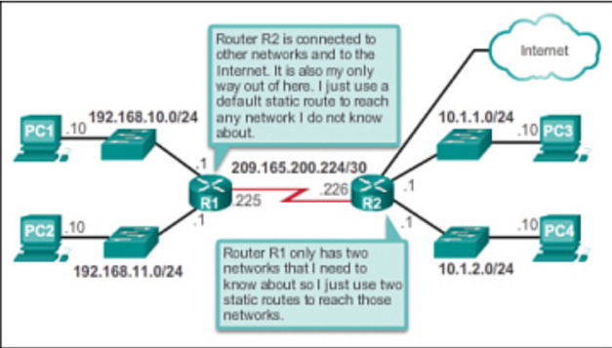
The disadvantages of static routing include:
- They are not easy to implement in a large network.
- Managing the static configurations can become time consuming.
- If a link fails, a static route cannot reroute traffic.

Static Routing Advantages and Disadvantages
Advantages | Disadvantages
Easy to implement in a small network. | Suitable for simple topologies or for special purposes such as a default static route.
Very secure. No advertisements are sent, unlike with dynamic routing protocols. | Configuration complexity increases dramatically as the network grows. Managing the static configurations in large networks can become time consuming.
It is very predictable, as the route to the destination is always the same. | If a link fails, a static route cannot reroute traffic. Therefore, manual intervention is required to re-route traffic.
No routing algorithm or update mechanisms are required. Therefore, extra resources (CPU and memory) are not required.

Dynamic Routing:
- In dynamic routing, routing entries are auto-generated by routing algorithms. Hence, the administrator does not have to do any manual editing.
- Routing algorithms are complex mathematical algorithms where the routers advertize about their links and using that information, the most ideal routes are calculated.
- There are different methods depending on how advertising and calculations happens. Link state algorithms and distance vector algorithms are two such famous methods.
- OSPF (Open Shortest Path First) is an algorithm that follows a link state algorithm and RIP (Routing Information Protocol) is an algorithm that uses distance vector algorithm. For modern large networks that involve a lot of changes during operation, dynamic routing is ideal.
- In dynamic routing, routing tables are periodically updated and hence, if any change has occurred, the new routing tables would be formed according to them. Another advantage is that in dynamic routing, depending on the congestion, the routing is adapted. That is, if a certain path is too much congested, routing protocols would figure them out and those paths would be avoided in the future routing tables. The drawback of dynamic routing is that the calculation is complex that it would need considerable amount of processing. Therefore, the cost of such routing hardware would be costly.

Dynamic Routing Advantages and Disadvantages
Advantages | Disadvantages
Suitable in all topologies where multiple routers are required. | Can be more complex to initially implement.
Generally independent of the network size. | Less secure due to the broadcast and multicast routing updates. Additional configuration settings such as passive interfaces and routing protocol authentication are required to increase security.
Automatically adapts topology to reroute traffic if possible. | Route depends on the current topology.

Types of Dynamic Routing
There are two types of dynamic routing protocols
- Distance vector protocols
- Link state protocols
